**LOAN DATABASE**

The Loans are type of credit in which different type of Loans are lent to borrowers by private banks or government and expected to be paid in the future with interest or without interest. The Loans plays crucial role to facilitate the business around the world. With the help of banks or government, people can get loans for mortgage, auto, student and personal purpose. To avoid complexity and data loss, database is required to keep track or record or manages the bank’s or government’s or company’s daily activities.

**List of Tables in Loan Database**

* Borrower
* Employment_Detail
* Monthly_Income_Expense
* Loan_Application_Detail
* Loan_Contract
* Loan_Payment
* Branch
* Loan_Officer_Info
* Employemt_Status
* Mortgage_Loan
* Auto_Loan
* Bank
* Loan_Type
* [State]
* Application_Status
* Personal_Loan
* Loan_Status

**Tech Data Loan Application ER-Diagram**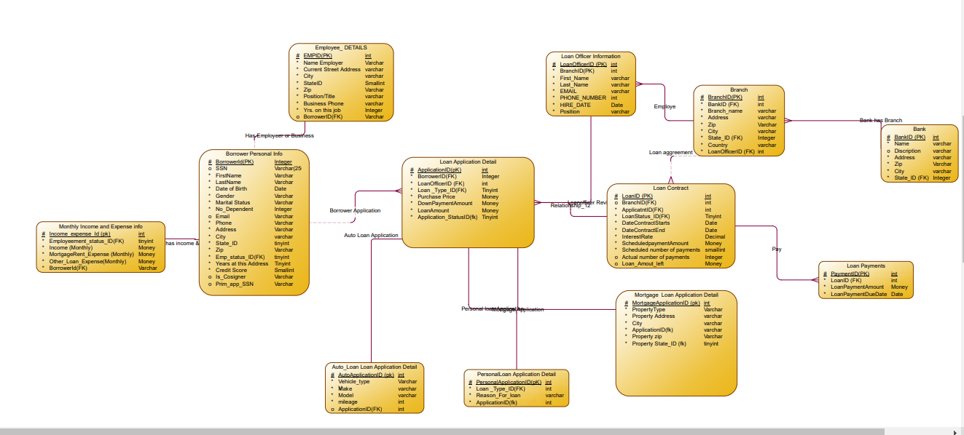

**Loan_Application_Detail:**

* **ApplicationID**-This is the unique ID of Loan_Application_Detail
* **LoanOfficerId**- This is the ID the Loan_Officer which is referring to the column LoanOfficerID of Loan_Officer table.
* **Loan_Type_Id**-This is ID for Loan Type which is referring to column Loan_Type_Id for Loan_Type table.
* **Down_PaymentAmount**- This is the down payment of for loan that will be taken by Borrower.
* **Purchase_Price**- This purchase price is the amount Borrower will pay for the Auto or Mortgage using the loan.
* **LoanAmount**- The LoanAmount is the total loan amount the borrower will borrow.
* **Application_Status_Id**- This is the ID of Application Status which is referring to the Column Application_Status_Id of Loan_Status table.
* **Borrower_Id**- This is the ID of Borrower which is referring to the column Borrower_ID of Borrower table.
* Application_Date- This is the Application date that application was filled.

**Loan_Contract:**

* **LoanID**-This Is the Unique Id of Loan_Contract table.
* **Branch_Id**- This is the Id of Branch which is referring to the column BranchId of Branch Table.
* **ApplicationID**- This is the Id of Loan Application Detail which is referring to the column ApplicationID of Loan_Application_Detail Table.
* **DateContractStarts**-This will hold the date when the contract does start, and it should not be future date.
* **DateContractEnd**- This will hold the date when the contract does end, and it should not be past and Present date.
* **InterestRate**-This holds the interest rate of that loan that will be taken.
* **Purchase_Amount**- This is the purchase amount of that the loan is going to be used for.
* **ScheduledPaymentAmount**-This schedule payment amount is that the borrower will agree to pay periodically.
* **ScheduledNumberOfPayment**- This payment is the number of Payment that the borrower agree will pay the schedule payment.
* **ActualNumberOfPayment**- This payment is the number of payment that the borrower actually paid the schedule payment.
* **Loan_Status_Id**-This the ID of Loan Status which is referring the column Loan_Status_Id of the Loan_Status Table
* **LoanAmountLeftof**- This is the amount of money that is left off after the borrower make a payment each time.

**Loan_Payment:**

* **PaymentID**-This is the Unique Id of Loan_Payment table.
* **LoanID**-This is the ID of Loan_Contract which is referring the column LoanId of Loan_Contract Table.
* **LoanPaymentDueDate**-This is the due date of each payment the borrower scheduled to pay.
* **LoanPaymentAmount**-This is the amount of the payment borrower will pay each time on the due date

**Mortgage_Loan:**

* **MortgageLoan_ID**-This is the unique Id of Mortgage_Loan.
* **Property_Type**-This is holds what type of mortgage property the borrower applying loan for.
* **Property_Address**-This holds the property address that the borrower applying loan for.
* **City**-This holds the property address the borrower applying loan for.
* **State_Id**- This ID is State ID which referring to column StateID for State Table
* **Property_zip**- This holds the property address that borrower will buy and it also should be 5 or 9 numbers.
* **ApplicationID**- This is the Id of Loan Application Detail which is referring to the column ApplicationID of Loan_Application_Detail Table.

**Auto_Loan:**

* **Auto_Loan_ID**-This is the unique Id of the Auto_Loan Table.
* **Vehicle_Type**-This holds what type of vehicle the borrower applying loan for.
* **Make**- This is for the Make of the car the borrower applying loan for.
* **Model**- This is for the Make of the car the borrower applying loan for.
* **Model_Year**- This is for the year of the car the borrower applying loan for.
* **Mileage**- This is for the Mileage of the car the borrower applying loan for.
* **ApplicationID**- This is the Id of Loan Application Detail which is referring to the column ApplicationID of Loan_Application_Detail Table.

**Personal_Loan:**

* **PersonalLoan_ID**-This the Unique ID for Personal_Loan Table.
* **Loan_Type_Id**- -This is ID for Loan Type which is referring to column Loan_Type_Id for Loan_Type table.
* **Reason_For_Loan**-This holds for what the borrower intends to use the loan for.
* **ApplicationID**- This is the Id of Loan Application Detail which is referring to the column ApplicationID of Loan_Application_Detail Table.